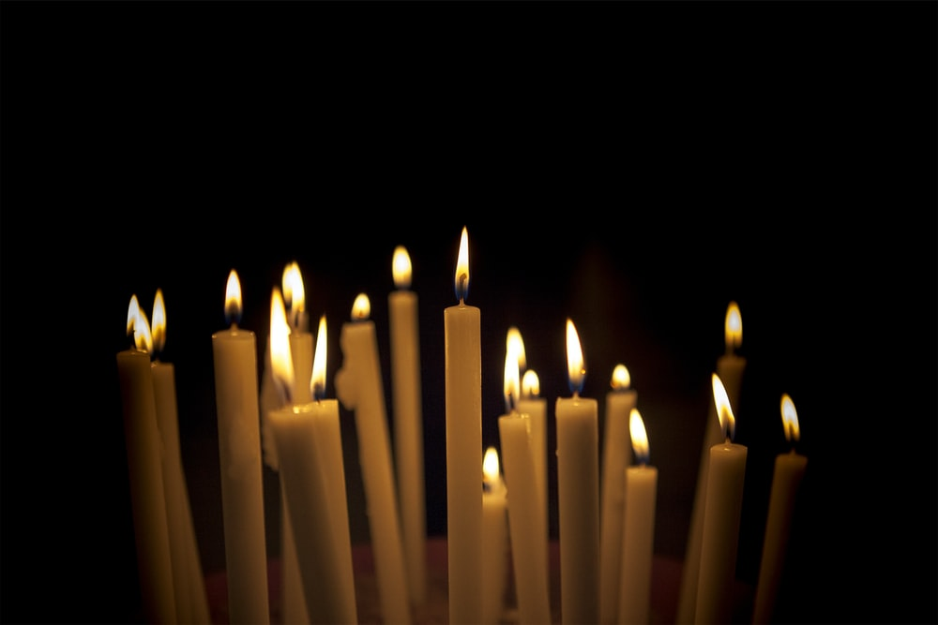
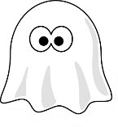
10 things to do at Halloween

Seeing as Halloween is cancelled, and no one is allowed to do trick or treating I have come up with some ideas to still celebrate Halloween but a little differently
- Watch a scary movie. A classic!! Get creative and make Halloween snacks sit back and relax and get spooked or create a spooky popcorn bucket from a large bowl and covering it with scary faces
- Play hide and seek in the dark. For 2 or more players. Turn all the lights out hide or count to 10 make sure to do it only on 1 floor so no accidents occur and when the seeker has found the hider scare them as much as possible. To make it extra scary
- Do some Halloween based arts and crafts and display them in the windows to make it look extra spooky!!!!!
- Halloween disco with the family put some Halloween tunes on and dance the night away have some spooky snacks out to make it a proper disco
- Halloween games night if you have some toilet rolls hanging about the house and a pumpkin spare create Halloween 10 pin bowling or it you have some sweets can create a Halloween sweet hunt
- Halloween pumpkin carving grab a pumpkin get the kids involved and try and make it a competition who can create the scariest pumpkin or who can do the best self portrait of themselves or just grab some inspiration from the internet.
- Create some DIY costumes which are made of things from around the home like toilet paper mummies or sheet ghosts. You could also do Halloween make up with face paint.
- Halloween baking I’m guessing we all did baking during lockdown now put your skills to the test by baking Halloween themed biscuits, cakes and savoury dishes and can even make it into competition if you have a competitive side
- Have a virtual party get a load of mates on zoom, snapchat or discord put some music on and dance the night away you could even create a public playlist on Spotify and add songs to it together to create an amazing Halloween playlist.
- If you’re into costume makeup or makeup in general try and create a gothic and Halloween themed look there are lots of YouTube videos with guides on how to create the best Halloween looks

