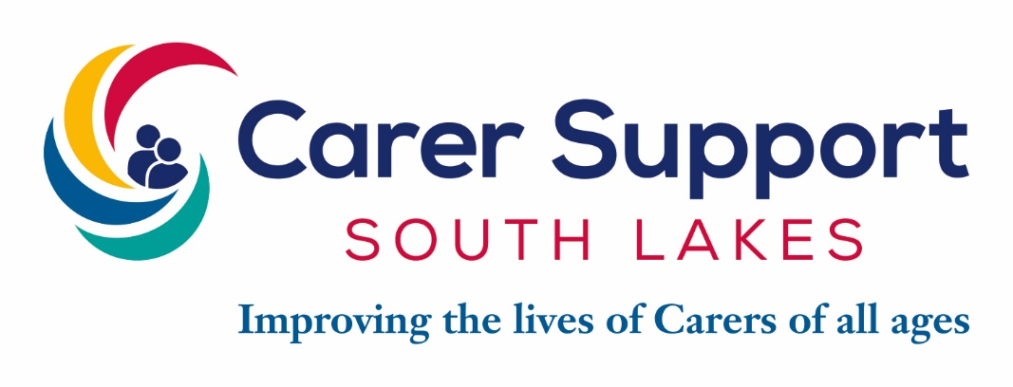

JOB DESCRIPTION

POST: Project and Support Coordinator
REPORTS TO: Chief Operating Officer
GRADE & SALARY: NJC SCP 11 £21,748 FTE
HOURS: Fixed Term Contract for 6 months
LOCATION: South Lakeland

CONTEXT
2017 was the 25th anniversary of Carer Support South Lakes (CSSL) in the beginning, CSSL provided support to 15 carers. During the intervening period, the organisation has evolved so that today it is supporting 1223 unpaid Carers of all ages.
Carer Connect is a unique service offered to Carers initially in South Lakes. Carer Connect is virtual platform for Carers to interact with one another at a time that suits. The platform will include a help line and a private space for one to one work along with a chat room.

PURPOSE AND KEY OBJECTIVES
- Meet the outcomes identified and project delivery for the Carer Connect project
- Provide information and emotional support to Carers so they feel less isolated, develop strategies with the carer to manage their own health and wellbeing to enable them to continue in their caring role
- Onward refer to appropriate services including Carer Support South Lakes.

MAIN TASKS & RESPONSIBILITIES

- Support the development of Carer Connect.
- To work in line with the Administrative Support Worker dedicated to Carers Connect
- Work with Carers to identify their needs, to inwardly signpost for a Carers Assessment and other organisations that meet the needs of individual Carers
- To provide qualitative information reports to the Chief Operating Officer, to include case studies and the recognised difference that Carer Connect has made in the lives of Carers.
- To work in accordance with the Pan Lancashire Safeguarding Protocol

- To attend carers events, meetings, forums and deliver presentations as required
- To carry out other such relevant duties as required by this post.

ORGANISATIONAL REQUIREMENTS OF EMPLOYEES
- Carry out duties in accordance with legislative and regulatory requirements
- Carry out duties in accordance with CSSL policies and procedures, including Health and Safety, Confidentiality, Equal Opportunities and Data Protection
- Contribute to the overall achievement of CSSL mission and objectives
- Adhere to our Values and Behavioural Framework
- Ensure the values of CSSL are upheld across the organisation
- Assist CSSL in Community Fundraising initiatives
- Promote CSSL social enterprise initiatives
- Participate in fundraising activities with and on behalf of Carer Support South Lakes
- Participate as part of the requirements of CSSL to meeting their ISO 9001 Quality Award standards
- Provide a supportive working environment to all staff and volunteers
- Attend regular supervisions, staff and team meetings as requested
- Contribute to research and reports

This job description outlines the principal responsibilities and duties of the post holder. It is not meant to be, nor is it, an exhaustive list of specific responsibilities and duties. The post holder will be expected to undertake any other duties which could reasonably be expected as being within the remit of the post and which arise out of evolution as the organisation develops, changes of legislation, regulations, orders, rules and working practices, methods and procedures and reviews, as directed from time to time.

PERSON SPECIFICATION

ESSENTIAL | DESIRABLE
Qualifications
- Good education attainment at Secondary School  - English and Maths Grade A-C | - Relevant qualification or training in Health and Social Care/ Social Work/ Nursing at level 3 or above
Experience of
- Working directly with Carers  - Working on own initiative  - Understanding and experience of working in a rapidly changing environment  - The ability to relate purposefully and sensitively and communicate well.  - To have an understanding and knowledge of working with digital platforms to include ZOOM | - Multi-disciplinary working  - Working with or within the voluntary sector  - Working with / in the health and social care services and community provision  - To have knowledge of services which support unpaid Carers
Knowledge
- Understanding of Issues affecting carers with long-term disabilities and illnesses  - The Care Act – Carers Assessments and Care Support Needs Assessment for people they care for  - Good working knowledge of other assets, services and organisations within S lakes to support Carers and the people they care for  - Relevant legislation including H&S and Mental Capacity Act  - To have knowledge of the impact that the caring role has on unpaid Carers | - The work of Carers’ Associations  - The work of Social Services in relation to Carers and the Cared-for  - Welfare Benefits  - National Care Standards  - Cumbria County Council’s Adult Safeguarding Policy
Skills
- Excellent writing and verbal communication with a wide range of audiences  - IT literate (Microsoft) in particular, managing database  - Excellent communication skills  - The ability to prioritise and organise under pressure | - Excellent presentational skills  - Knowledge of fundraising  - Line management responsibilities
Qualities
- Ability to relate to Carers and Cared-for  - Ability to plan, work and organise under pressure to work on own initiative and as part of a team  - Commitment to Equal Opportunities, Cultural Diversity and exceptional customer service  - Ability to manage own professional and personal development and a willingness to learn  - The ability to relate to and empathise with Carer’s and the people they care for | - Ability to respond to new situations  - Ability to communicate well written reports  - Ability to drive and have access to a car

TO APPLY FOR THIS POSITION

You must complete an application form, Rehabilitation of Offenders Act 1974 (Exception) Order 1975 form and equal opportunities monitoring form available to download from the CSSL website www.carersupportsouthlakes.org.uk. in Word and PDF formats. You may attach a letter but please do not send photographs. We do not accept CVs.

In completing your application, you must tell us how you meet the essential qualification, experience, skills and qualities outlined in the Job Specification. We will assess how you meet them through the application form and interview. We will let you know if we will include a presentation or a skills should you be selected for interview.

DEADLINE FOR RECEIPT OF APPLICATIONS
This vacancy closes 20th September 2020 any forms received after this time will not be processed.

Your completed application form, Rehabilitation of Offenders Act 1974 (Exception) Order 1975 and equal opportunities monitoring form should be returned by one of the following methods:

By email:
Please email marian@carersupportsouthlakes.org.uk there is no need to send additional copies. If successful, you will be asked to sign your electronic application form at interview. Please note that our email servers will not accept emails larger than 10MB.

By post:
Marian Graveson, Business Development Manager
Carer Support South Lakes
Stricklandgate House, 92 Stricklandgate, Kendal. Cumbria. LA9 4PU

ACKNOWLEDGEMENT OF RECEIPT
Email applications will be acknowledged when we receive them. Should you wish to receive an acknowledgement for a postal application, please include a self-addressed envelope with a 1st or 2nd class stamp and we will return this to you.

INTERVIEWS
Interview date week commencing the 28th September 2020

