How to make a origami elephant
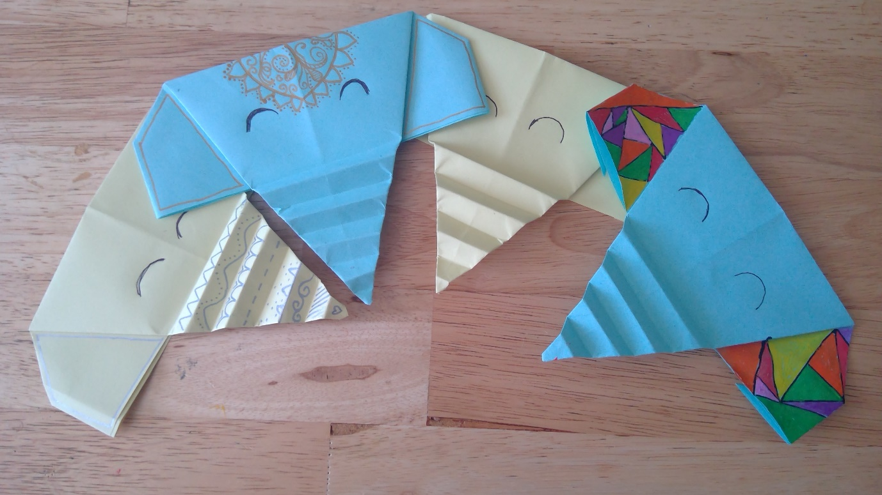
Kit list
- A4 piece of paper
- Scissors
- Colouring pens (optional)

Instructions
- Take your A4 piece of paper

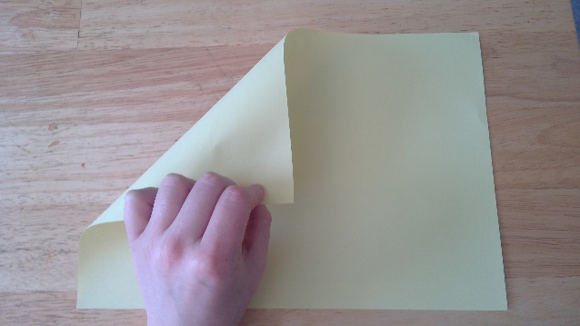
- Take left hand corner of a A4 piece of paper and fold it down to the bottom of the paper towards the right-hand corner

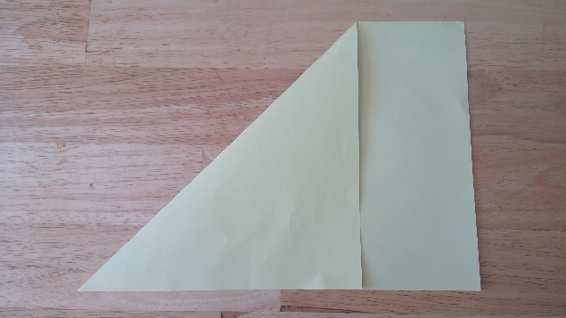

- There should be a rectangular piece of paper at the bottom of the traingle

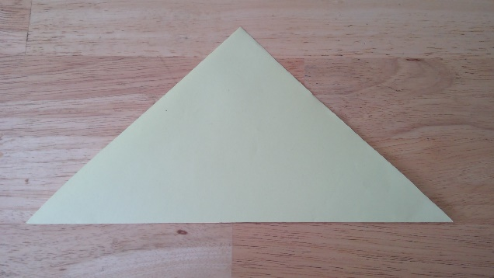

- Using scissors cut the rectangle of

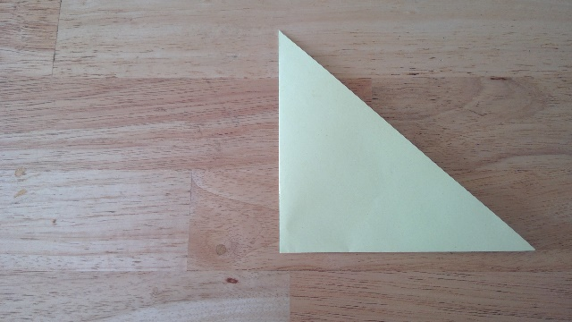

- Fold the triangle again in half

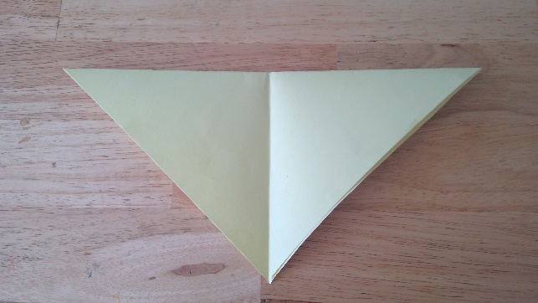

- Unfold the triangle

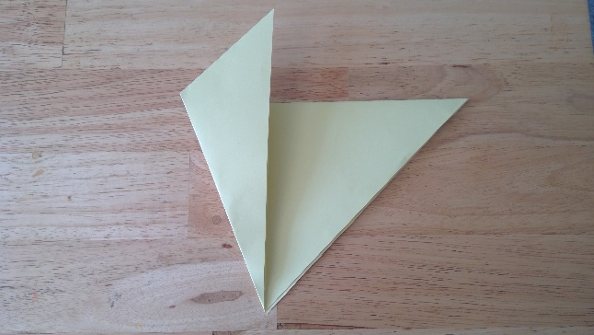

- Take the left-hand edge and fold up to the middle

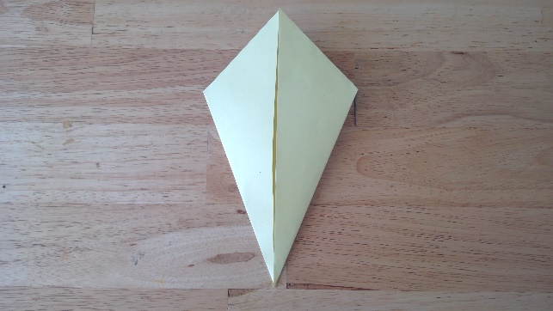
- Now take the right-hand edge and fold up to the middle

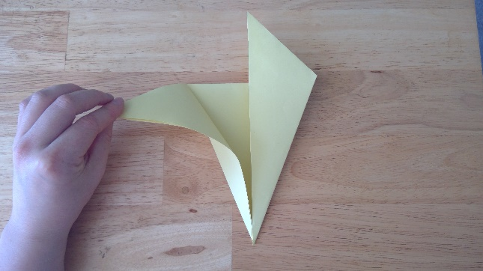

- Fold the left-hand side top corner to the side

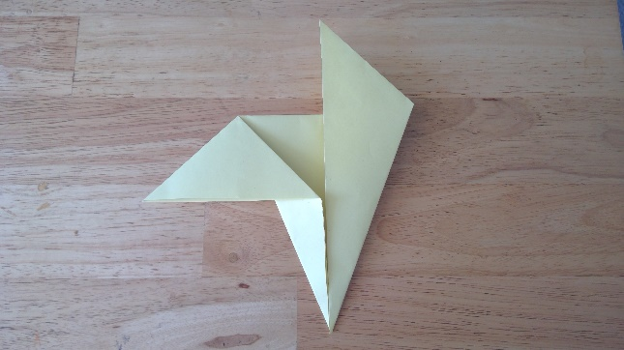
10. create a fold

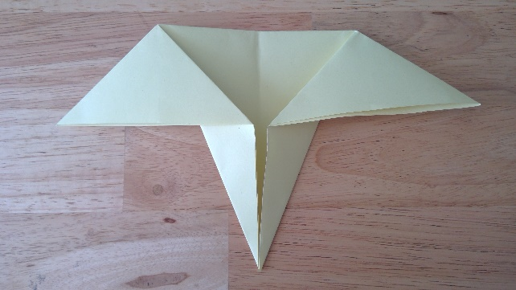

11. fold the right-hand side top corner to the side

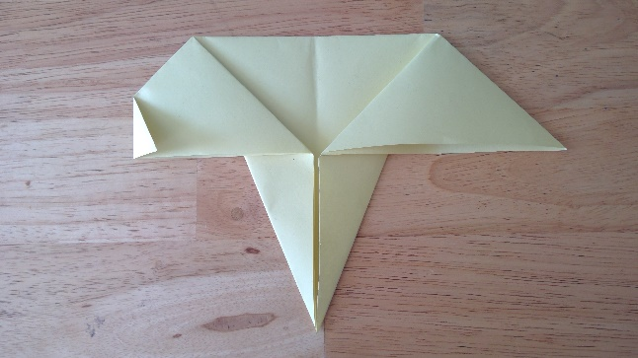
12. fold the corners of the ears of the elephant in

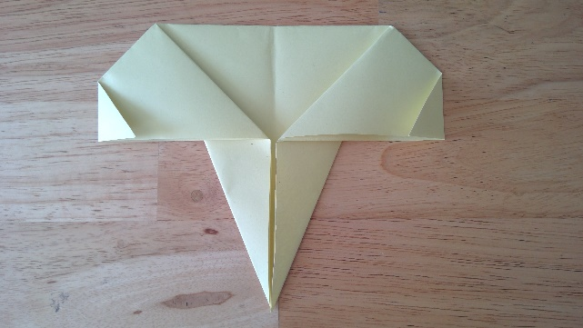

13. fold the right-hand corner in

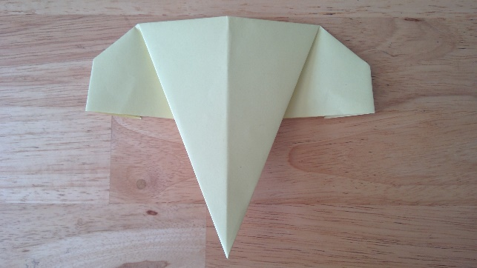

14. turn over

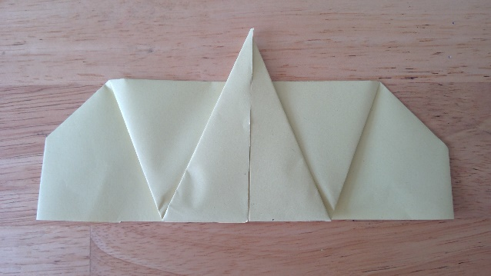

15. fold the tip of the triangle up

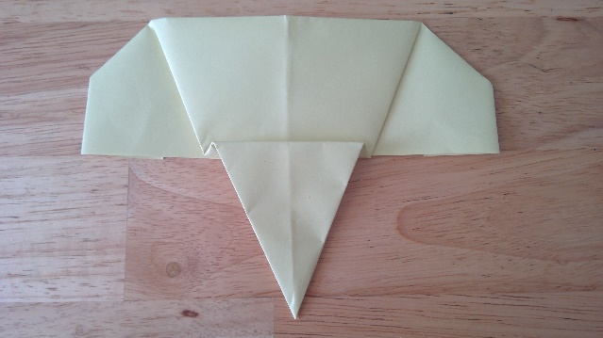

16. fold the triangle tip back down creating a pleat in the paper

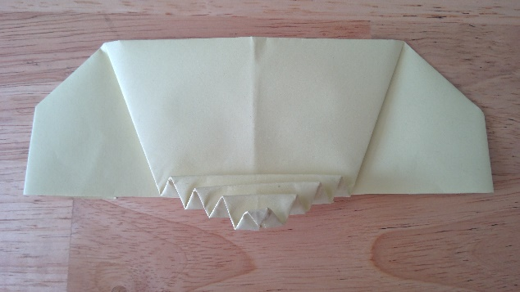

17. continue to create small folds in the trunk like an accordion

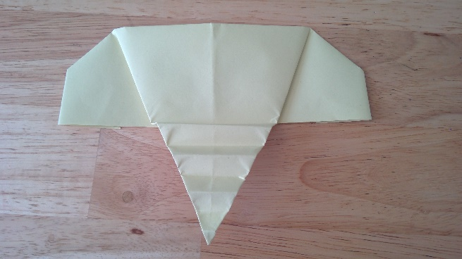

18. stretch out the folds in the trunk well done you have created an origami elephant

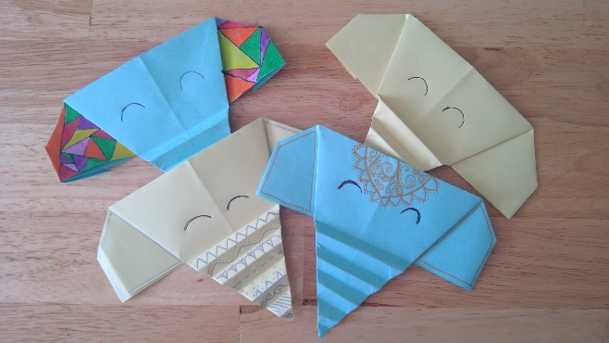

19. now you can decorate your elephant with pens, feathers or googly eyes it’s up to you!!

