How to make origami butterflies
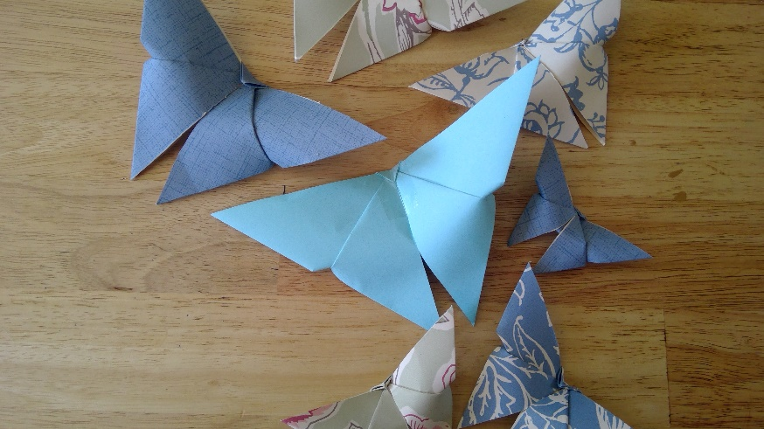
Kit list
- A4 piece of paper
- Glue or tape
- Scissors
Instructions
- Take your A4 piece of paper

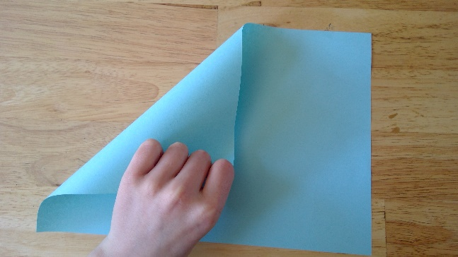
- Take left hand corner of a A4 piece of paper and fold it down to the bottom of the paper towards the right-hand corner

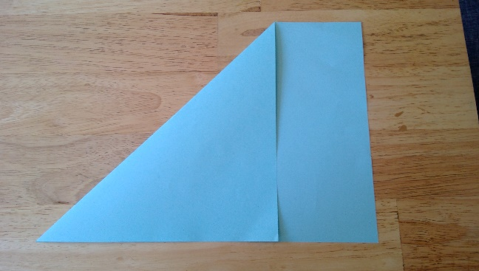

- There should be a rectangular piece of paper at the bottom of the traingle

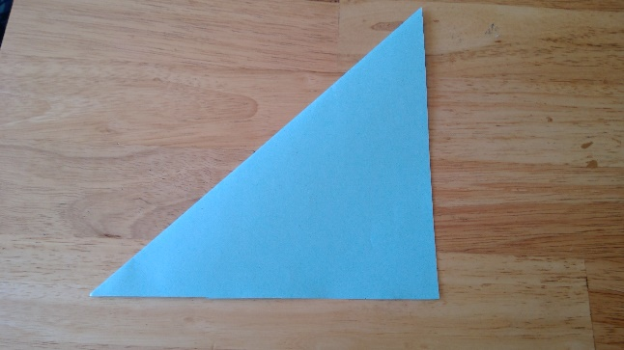
- Using scissors cut the rectangle of

- Unfold and you should have a square

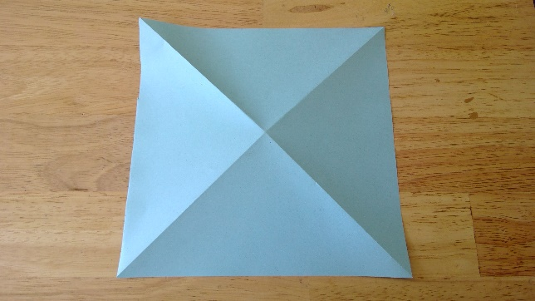

- Fold the piece of paper again diagonally in the opposite direction and turn over

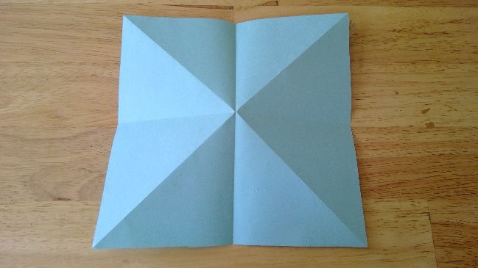

- Fold the piece of paper in half both ways and unfold

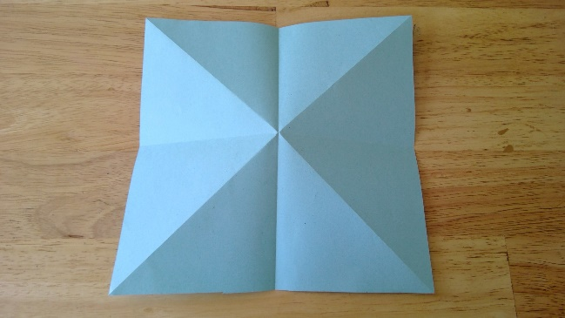

- Push the paper in from both sides

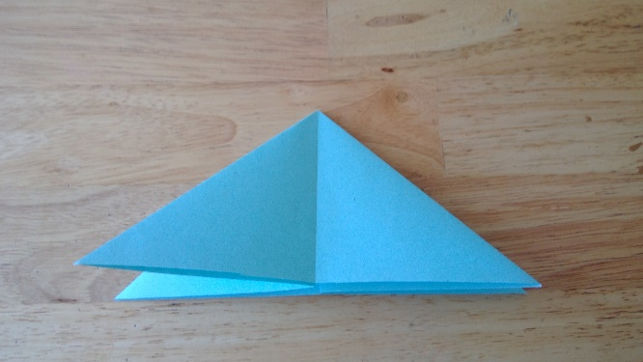

- It should look like this

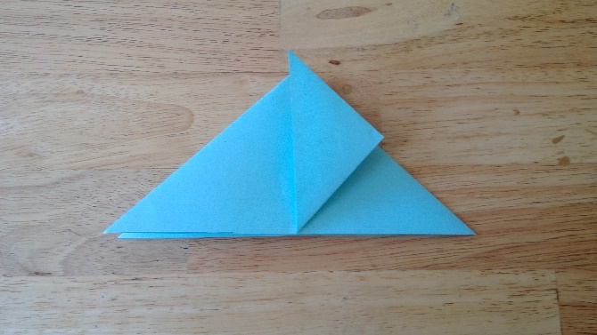

10. Take the bottom right hand corner and fold up to the centre

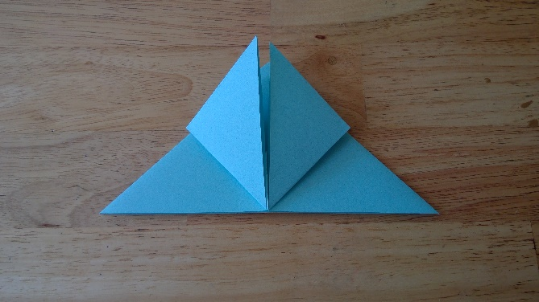

11. take the left-hand corner and fold up to the centre

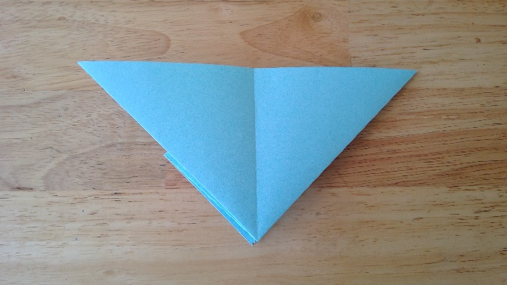

12. flip over

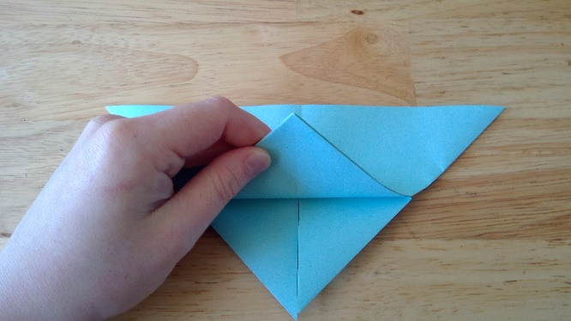

13. take the bottom of the triangle and fold up

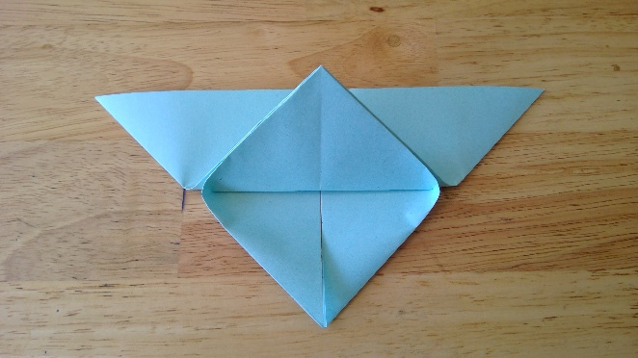

14. make sure that the point of the triangle overlaps the edge

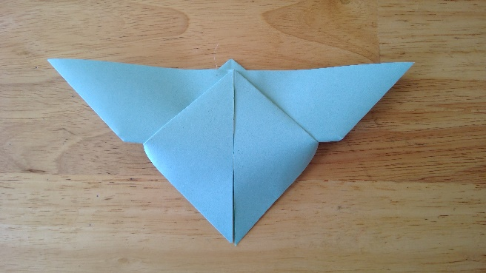

15. flip over the paper

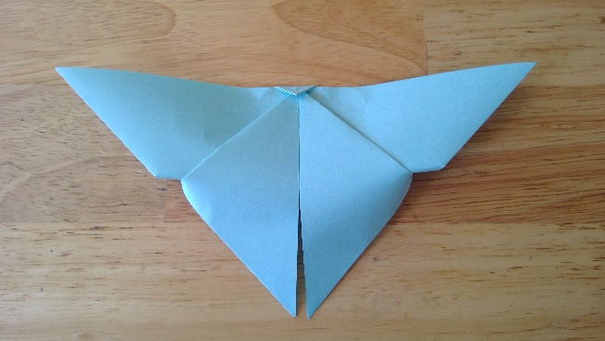

16. fold over the triangle sticking up down

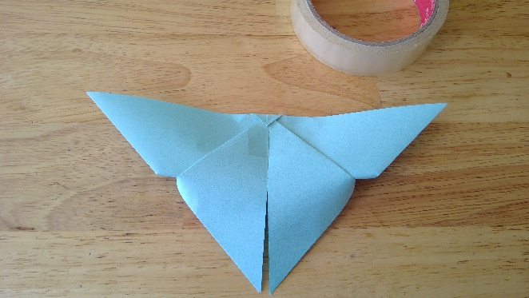

17. use a bit of sticky tape or glue to secure the fold you just made

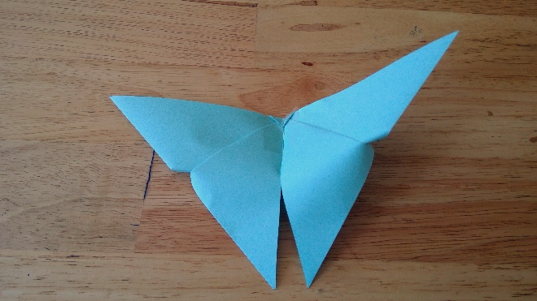

18. well done you have created an origami butterfly

